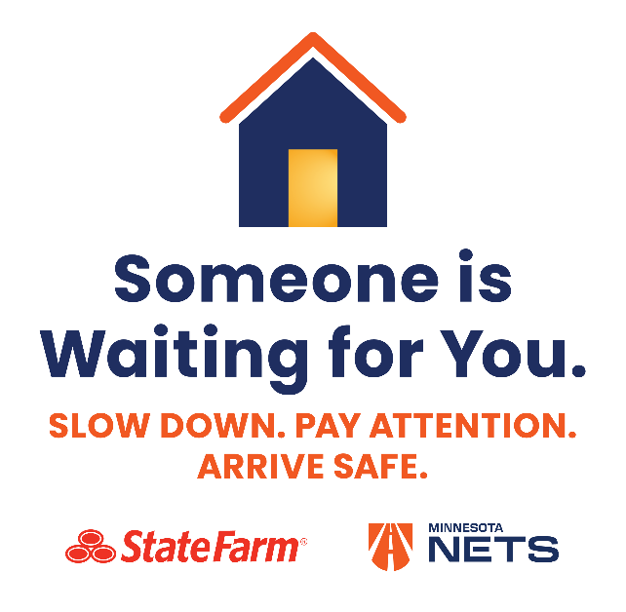

Headline: Someone Is Waiting for You — Arrive Safely

You’re busy. You’re running late. You’re multi-tasking while driving or pressing the gas pedal to the floor.

Suddenly you’re involved in a crash. You never arrive at your destination.

For most of us, each time we get behind the wheel there’s someone on the other end anticipating our arrival. Whether there’s a special celebration planned, an important project to finish or a pet food dish that needs filling, someone is depending on you.

But all that can vanish in an instant. One glance at a cellphone, an effort to retrieve a dropped item or other distraction can turn a routine trip into heartbreak for the spouses, children, friends and co-workers.

Distracted driving, including texting, remains a serious problem across the state. Minnesota Office of Safety reports that each year from 2019-2024 there were close to 30,000 distracted driving crashes, about 30 deaths, and 146 life-altering injuries. And behind every one of those deaths and injuries are family members, friends or coworkers whose lives have been irreparably changed by that loss.

This year’s Distracted Driving Awareness Month campaign reminds drivers that Someone is Waiting for You. It calls on every driver to slow down and pay attention each time they get behind the wheel. Follow these tips to drive safely and distraction‑free:
- Put your phone on Do Not Disturb or in hand-free mode before driving.
- Set navigation and music before you start moving.
- Adhere to the speed limit.
- Keep your eyes on the road, hands on the wheel and mind on driving.

