Think you’ve seen it all? Ask the law enforcement officers behind the wheel of the new Traffic Safety Vehicles now patrolling Minnesota roads. If you’re your hands and mind are on a sandwich, the cell phone in your hand or something else, you’re distracted. In 2023, distracted driving contributed to an estimated 2,165 injuries and 33 deaths in our state. #DoItforThem #DoItforME #INeedYou #slowdown #payattention #drivesafemn #statefarm

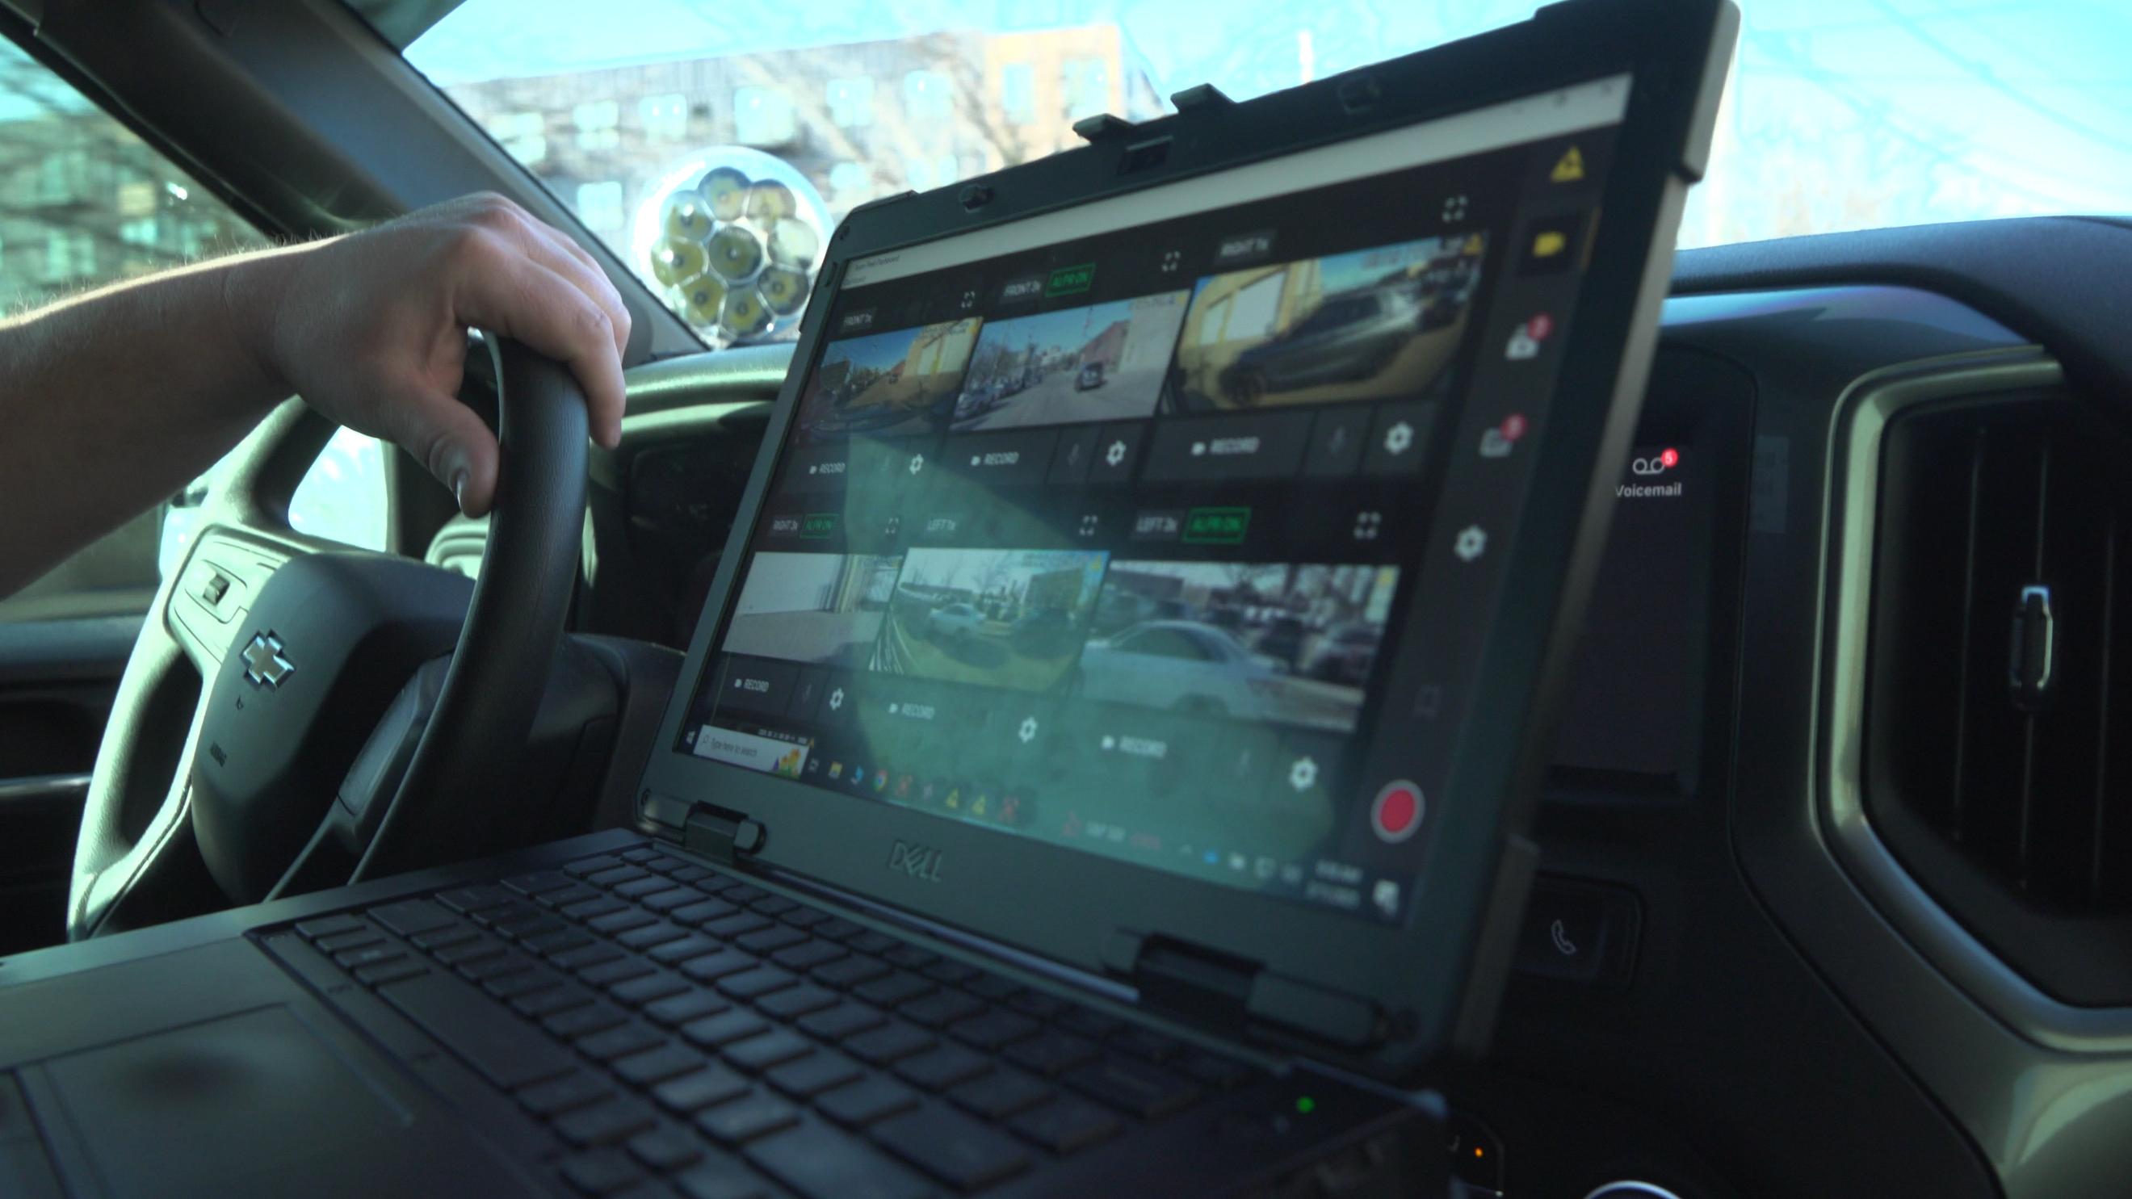

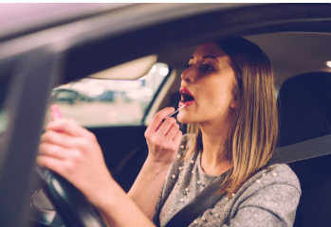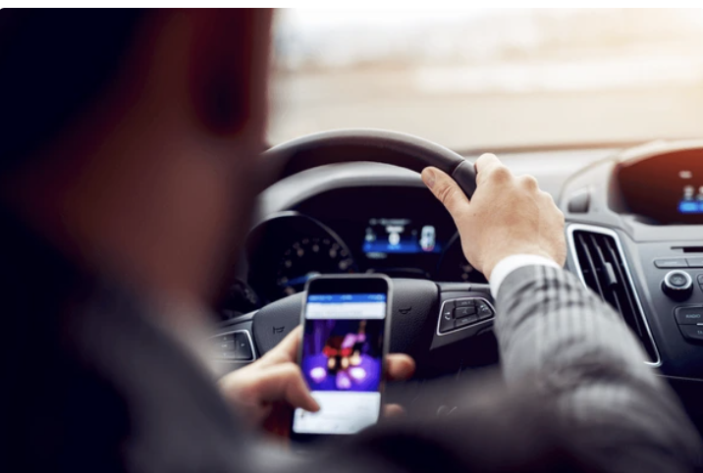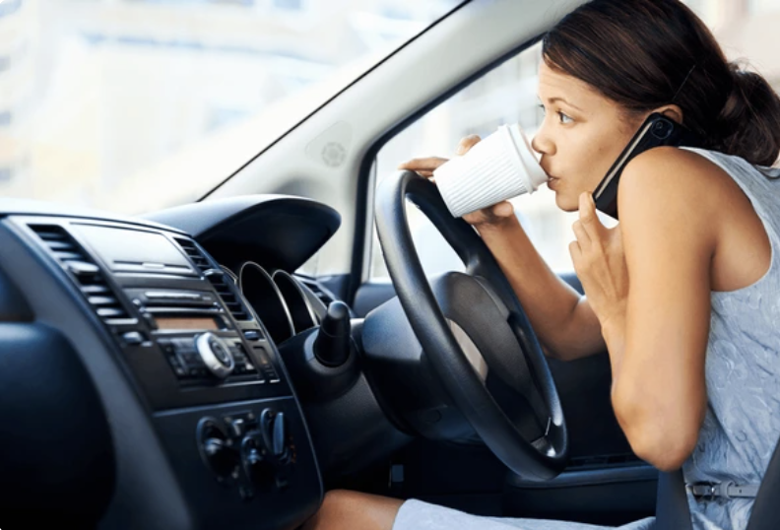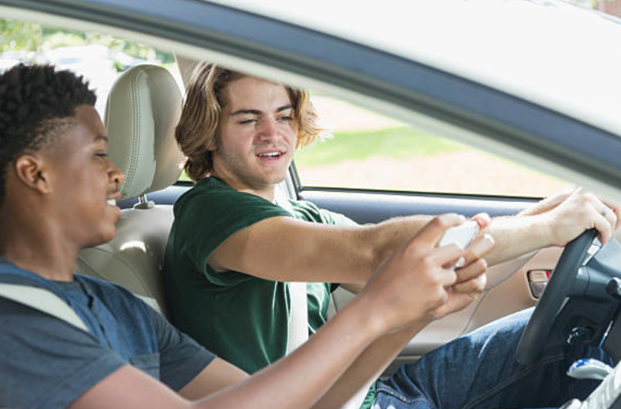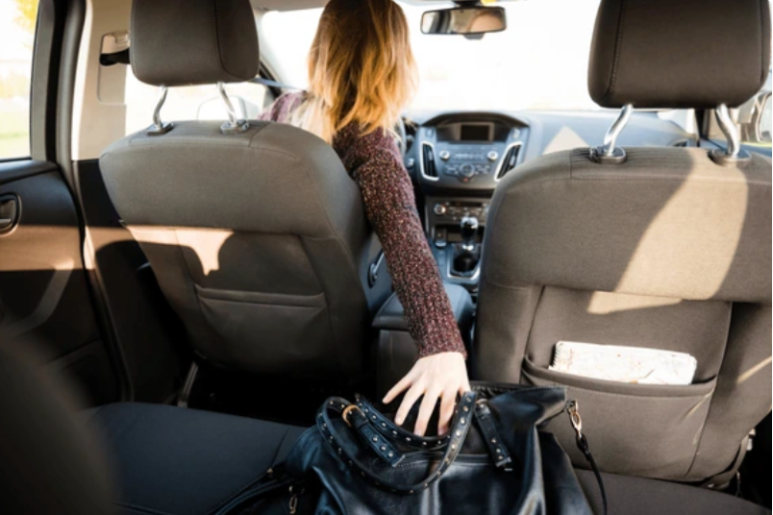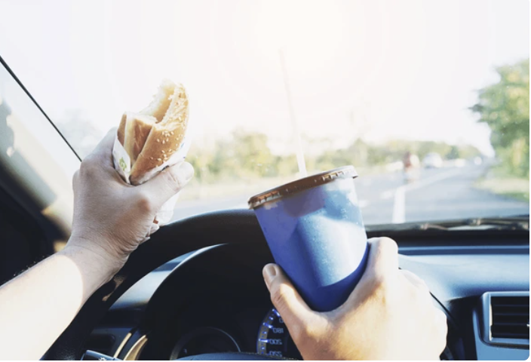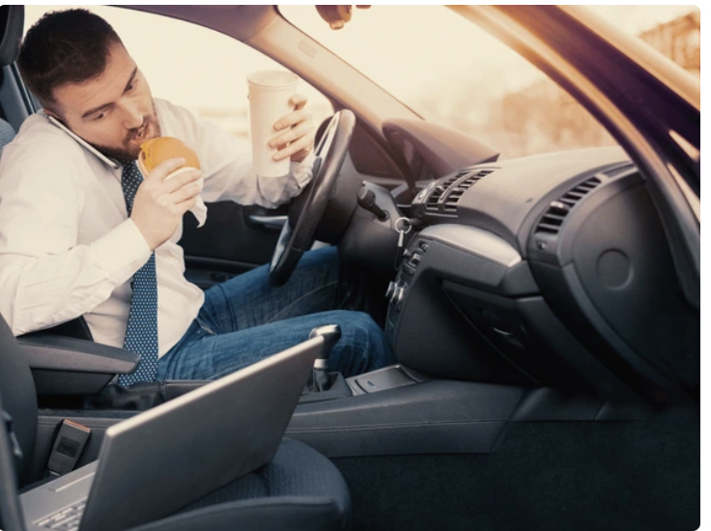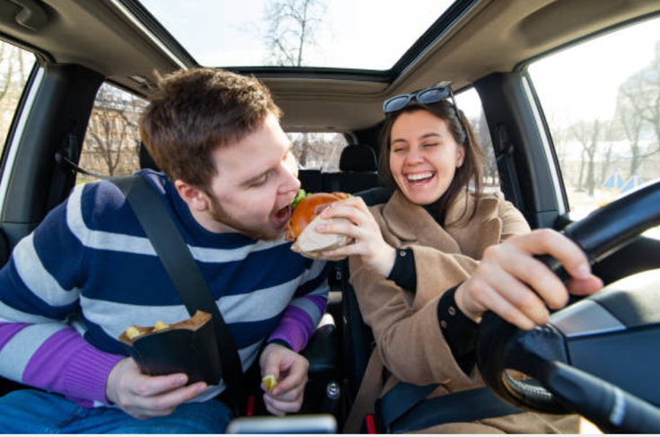
Are you phone-fixated behind the wheel? Minnesota law prohibits use of cell phones while driving unless they’re hands-free. If your hands, eyes and mind are on your phone, you’re distracted. In 2023, distracted driving contributed to an estimated 2,165 injuries and 33 deaths on our state’s roads. That’s not counting the impact on heartbroken loved ones awaiting their return. Who’s counting on you? Do it for THEM.
#DoItforThem #DoItforME #INeedYou #slowdown #payattention #drivesafemn #statefarm

Was this you the last time you got behind the wheel? Multi-tasking and driving don’t mix. In 2023, distracted driving contributed to an estimated 2,165 injuries and 33 deaths on our state’s roads. That’s not counting the impact on heartbroken loved ones awaiting their return. Who’s counting on you? Do it for THEM.
#DoItforThem #DoItforME #INeedYou #slowdown #payattention #drivesafemn #statefarm

This look like you? Doing everything but keeping your hands on the wheel, eyes on the road and mind on driving? Distracted driving is a major factor in crash deaths and injuries. In 2023 it contributed to an estimated 2,165 injuries and 33 deaths on our state’s roads. That’s not counting the impact on heartbroken loved ones awaiting their return. Who’s counting on you? Do it for THEM.
#DoItforThem #DoItforME #INeedYou #slowdown #payattention #drivesafemn #statefarm

That new video may be hilarious but it’s also a distraction – even in a passenger’s hands. In 2023, distracted driving contributed to an estimated 2,165 injuries and 33 deaths on our state’s roads. That’s not counting the impact on heartbroken loved ones awaiting their return. Who’s counting on you? Do it for THEM.
#DoItforThem #DoItforME #INeedYou #slowdown #payattention #drivesafemn #statefarm

Think this is safe? Your eyes may be on the road and one hand on the wheel, but you’re distracted and risk a crash. In 2023, distracted driving contributed to an estimated 2,165 injuries and 33 deaths on our state’s roads. That’s not counting the impact on heartbroken loved ones awaiting their return. Who’s counting on you? Do it for THEM.
#DoItforThem #DoItforME #INeedYou #slowdown #payattention #drivesafemn #statefarm

Lunch behind the wheel may save time but it’s a distraction. If your eyes aren’t on the road, hands aren’t on the wheel and mind isn’t on driving, you’re distracted. In 2023, distracted driving contributed to an estimated 2,165 injuries and 33 deaths on our state’s roads. That’s not counting the impact on heartbroken loved ones awaiting their return. Who’s counting on you? Do it for THEM.
#DoItforThem #DoItforME #INeedYou #slowdown #payattention #drivesafemn #statefarm

If this is your idea of a mobile office, it’s time to pull over. If your eyes aren’t on the road, hands aren’t on the wheel and mind isn’t on driving, you’re distracted. In 2023, distracted driving contributed to an estimated 2,165 injuries and 33 deaths on our state’s roads. That’s not counting the impact on heartbroken loved ones awaiting their return. Who’s counting on you? Do it for THEM.
#DoItforThem #DoItforME #INeedYou #slowdown #payattention #drivesafemn
Sure, it’s nice to share – but the next thing this driver and passenger share may be a crash. If your eyes aren’t on the road, hands aren’t on the wheel and mind isn’t on driving, you’re distracted. In 2023, distracted driving contributed to an estimated 2,165 injuries and 33 deaths on our state’s roads. That’s not counting the impact on heartbroken loved ones awaiting their return. Who’s counting on you? Do it for THEM.
#DoItforThem #DoItforME #INeedYou #slowdown #payattention #drivesafemn #statefarm

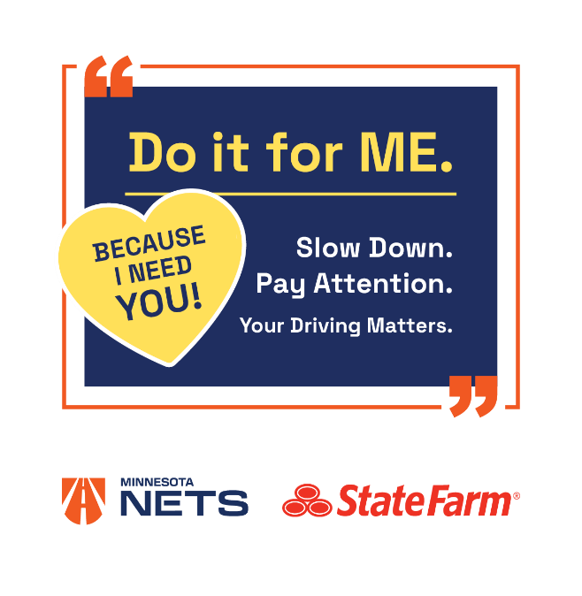
I’m really excited about the zoo – I just hope we get there safely. Put down your cell phone, keep your eyes on the road and your mind on driving. I need you to keep me safe. Who’s your somebody?! #DoItforThem #DoItforME #INeedYou #slowdown #payattention #drivesafemn #statefarm

Distracted driving and excessive speed continue to take lives on Minnesota roads – and devastate those left behind. The next time you’re tempted to drive distracted, think the loved ones riding with you or awaiting your safe return. They Need You! Do it for THEM! #DoItforThem #DoItforME #INeedYou #slowdown #payattention #drivesafemn #statefarm

