Spring 2024 “Do It for Me/Do It for Them” Speed and distraction campaign
State Farm agent communication (adapt for other audiences)
v.3.25.2025
you can find highlighted current data sets at the Department of Public Safety, Office of Traffic Safety homepage.

Dear State Farm Agent:

It’s no secret that the epidemic of dangerous driving practices continues to escalate on roads in Minnesota and across the U.S. As March winds down, Minnesota already has recorded xx crash deaths to date for 2024, up from xx a year ago at this time, as record warm weather and scant snowfall created prime conditions for excess speed and distracted driving.

The director of the Minnesota Office of Traffic Safety calls the situation “terrifying and it should terrify everybody who uses our roads out there.”

In partnership with the Minnesota Network of Employers for Traffic Safety (MN NETS), in April we’re introducing new campaign materials intended to build public awareness of the deep and lasting impact vehicle crash deaths and injuries have on those left behind. The campaign builds on the successful Fall 2023 “Do It for ME” program and calls on drivers to “Do It for THEM” through emotion-driven messages from loved ones.

The campaign, housed at DriveSafeMN, features five new videos suitable for presentations, websites and organization and personal social media accounts, along with fact sheets, safety talk outlines, newsletter article templates, social media profile frames and more.

In addition, we invite you to engage your clients through our social media campaign. Contact me to order a “Do It for ME” cardboard selfie frame you can use to snap and post customer photos to your website or social media.

Don’t hesitate to reach out if you have questions. And each time you get in your car, think of the voice of someone you love reminding you to slow down and pay attention. Do it for them!
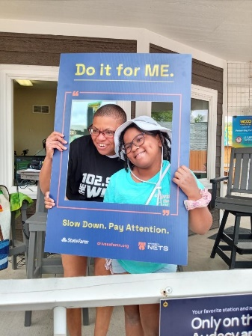
Sincerely,

