Selfie Frame

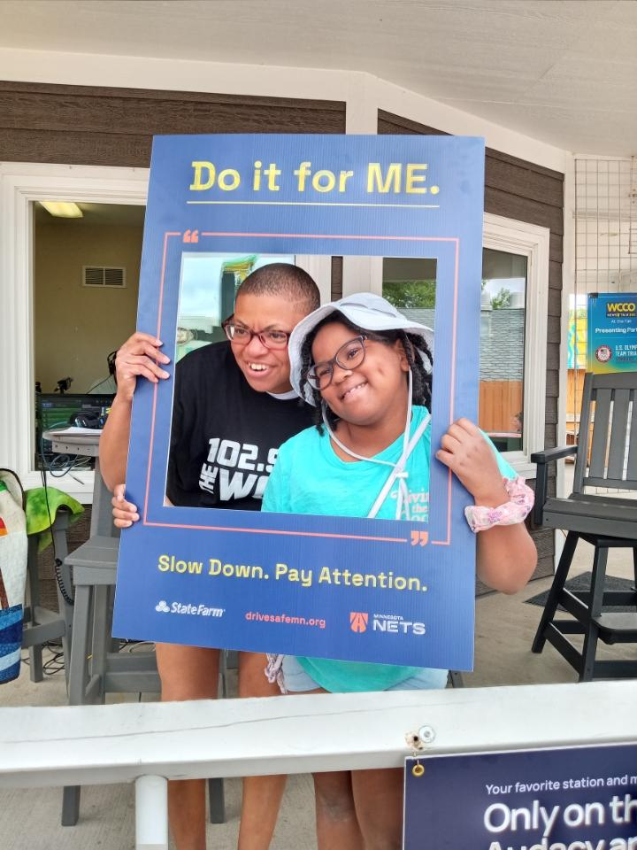
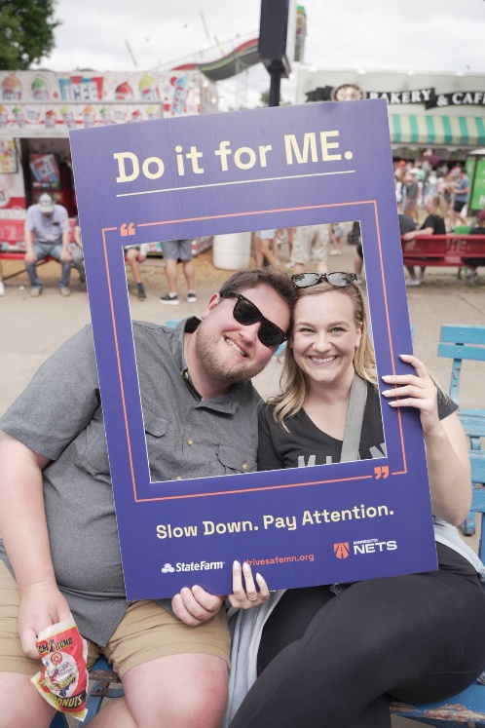

Banner

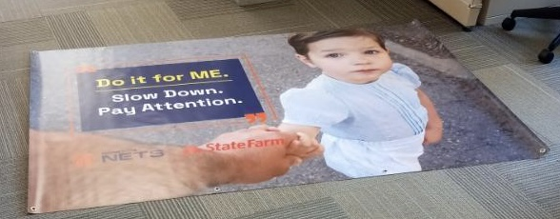

To reserve a selfie frame or banner for your next event contact: Lisa Kons at 651.228.7330 or lisa.kons@mnsc.org

