“Do It for ME”
Excessive Speed and Distraction Campaign
Tools for Educators

In a Nutshell
Minnesota and much of the nation is experiencing an epidemic of risky driving behaviors led by speed and distraction. These behaviors pose particular risk for teens behind the wheel and children who are either vehicle passengers or pedestrians. While traffic safety and law enforcement officials try to curb these dangerous behaviors through citations and education programs, preliminary research shows the voices of loved ones can make a difference.
Children, Teens and Excessive Speed and Distraction Facts
- Nationally, speeding was a factor in 29% of all traffic fatalities in 2021, killing 12,330, or an average of over 33 people per day.
- Young male drivers in the 15-20 and 21-24 year age groups were the most likely to be speeding at the time of fatal crashes. In 2021, at least 31% of male drivers in these age groups involved in fatal crashes were speeding at the time of the crash.
- Nationally, the percentage of speeding-related pedestrian deaths among children younger than 15 has more than doubled since 2018, from 5.8% to 11.9%.
- In 2020, seven percent of teen drivers 15 to 19 who were involved in fatal crashes were distracted at the time of the crashes.

Find tools you can use at DriveSafeMN.org/do-it-for-me/

Messages for signs and video marquees
- Do It for the Kids Inside. Slow Down. Pay Attention. Your Driving Matters.
- Headed home with the kids? Slow Down. Pay Attention. Your Driving Matters.

Images

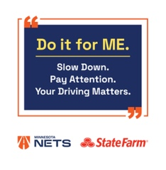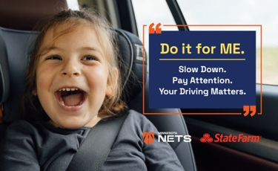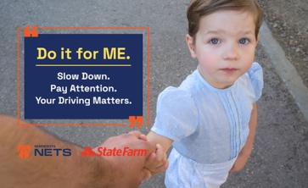

Video for website, in-school screens, meetings:
- Minnesota Mom Sheletta Brundidge says she’s committed to slowing down and paying attention when her four kids are on board. Available for download at DriveSafeMN.org/do-it-for-me/

Email message or article (can be customized with comments from school leader)

What would the children say about your driving?
“Slow down and pay attention. Do It for ME!”

You need only scan the daily news – or your own social media feeds – to witness the heartbreaking evidence and devastating impact of the current epidemic of excessive speed and distracted driving. Almost daily there are reports of drivers ticketed for going 100 mph or more, or worse yet, crashes caused by excessive speed, often with serious injuries or fatalities.

Far too often children are the victims as passengers or pedestrians. And significant numbers of teen drivers are involved in fatal or serious injury crashes due to excessive speed and/or distraction.

And even with Minnesota’s hands-free cellphone law, crashes involving a long list of distractions continue to be a cause of death or injury. In far too many cases, drivers are also travelling at excessive speeds AND distracted.

The tragic stories are rampant. Drivers know the law. Law enforcement agencies and traffic safety groups continue to work hard to educate on the dangers of excessive speed, distraction and more. But the crashes persist.

Making change may come down to listening to the voices of children.

“Preliminary results of research underway tells us the pleas of loved ones – especially when they’re passengers – can make a difference,” says Lisa Kons, coordinator, Minnesota Network of Employers for Traffic Safety. “Our new ‘Do It for ME’ campaign, in partnership with State Farm, uses the voices of loved ones to remind drivers to ‘Do it for me. Slow down. Pay attention.’”

To learn more about the campaign, visit DriveSafeMN.org/do-it-for-me

Sources: National Safety Council
National Highway Traffic Safety Administration
Governors Highway Safety Association

